DBC-2
75W & 150W

CONDUCTED – HARMONICS – RADIATED
Tests @Vestel

23.05.2023
Following tests hold for DBC 2 75W and 150W units accordingly. All images have labels to indicate which sample tested. For 150W tests ENKO Unit 150W-4 used. For 75W tests, ENKO Unit 1205-A used.

CONDUCTED EMISSIONS TESTS

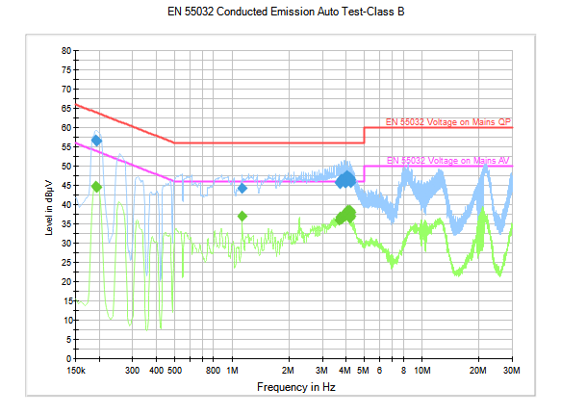
Image 1 – 150W-4 15VDC 10ADC Tests @Vestel

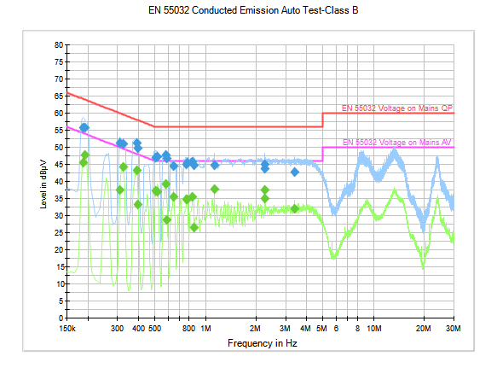
Image 2 - 150W-4 30VDC 5ADC Tests @Vestel

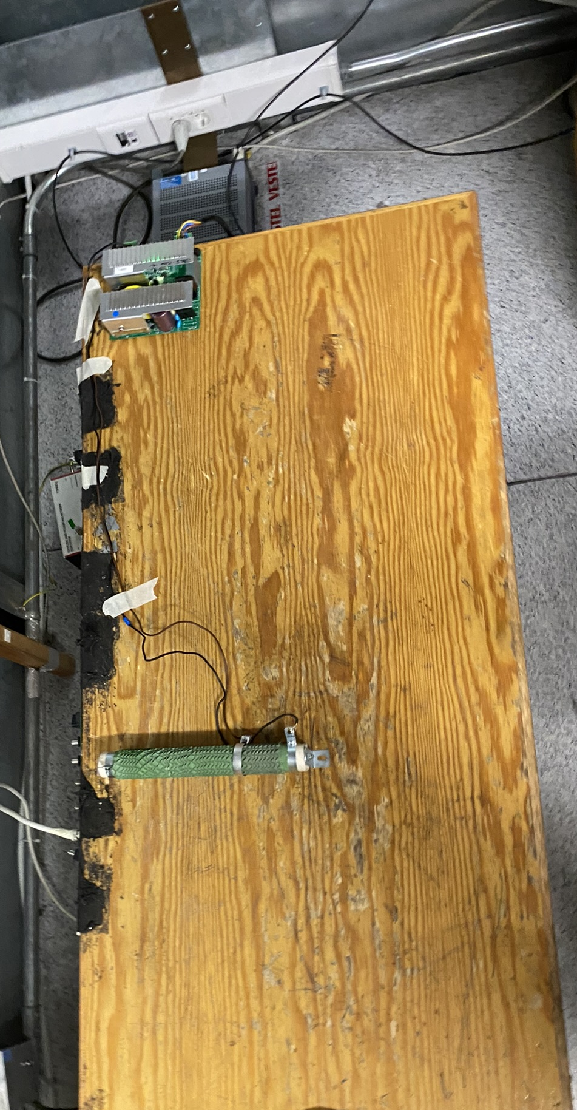
Image 3 – 150W-4 Conducted Test Setup @Vestel

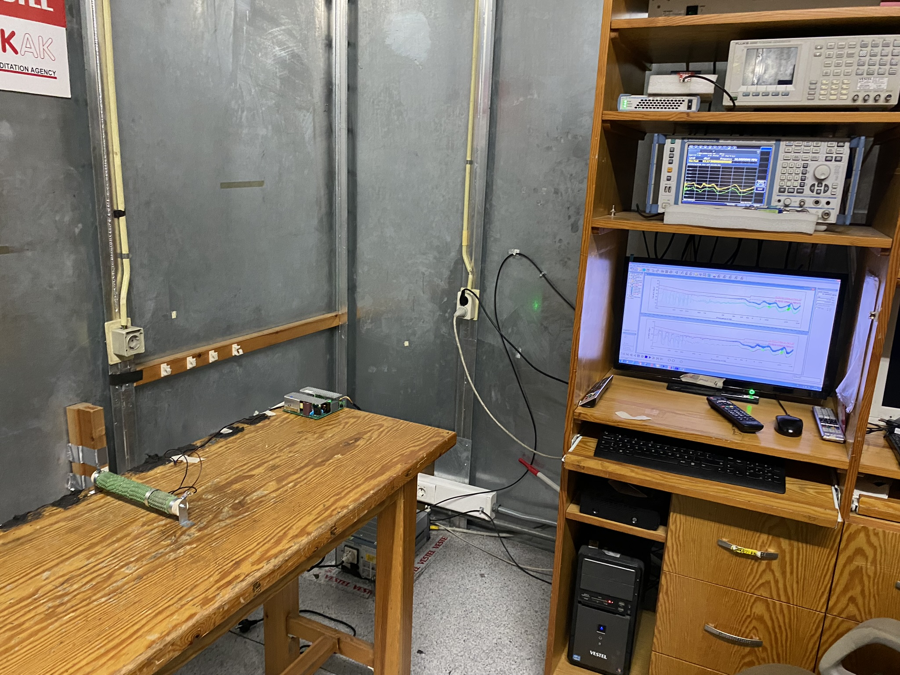
Image 4 – 150W-4 Conducted Test Setup @Vestel

Line Current Harmonics Tests

Harmonics tests at Vestel were according to standard: EN/IEC 61000-3-2 Ed.4 Long cyclic, Class A.

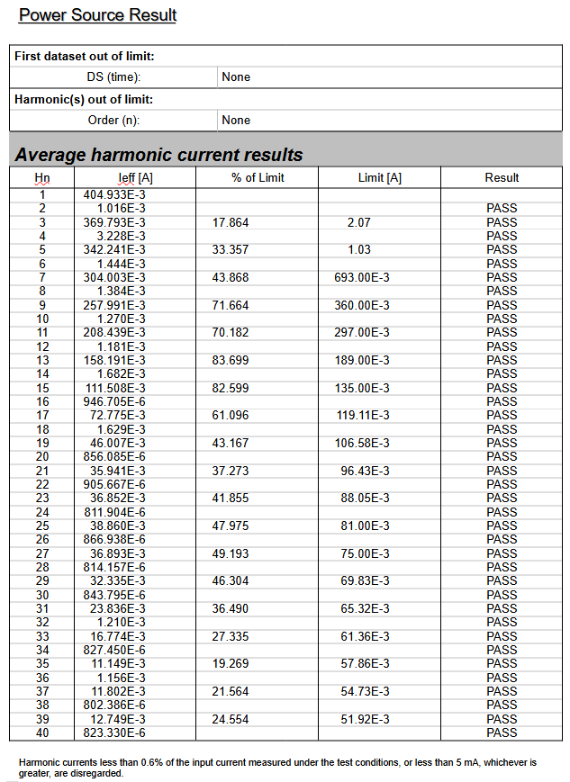
Image 5 – 1205-A 15VDC 05ADC Harmonics Test Average Results @Vestel
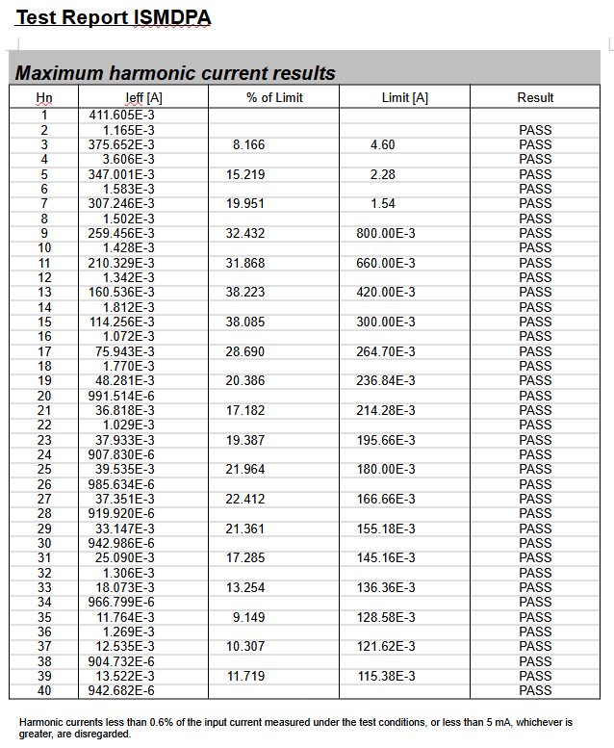
Image 6 – 1205-A 15VDC 05ADC Harmonics Test Maximum Results @Vestel

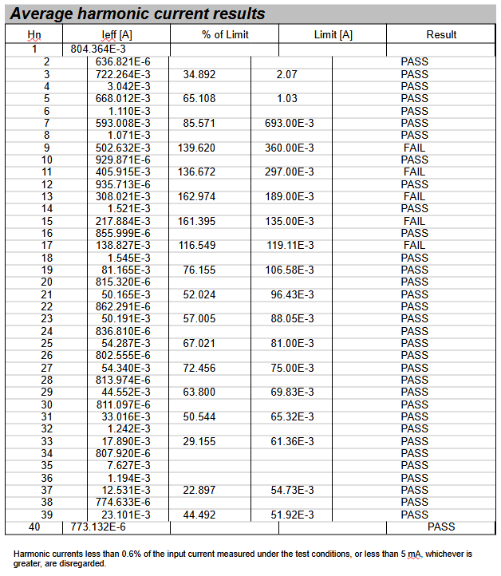
Image 7 – 150W-4 15VDC 10ADC Average Current Harmonics Test @Vestel

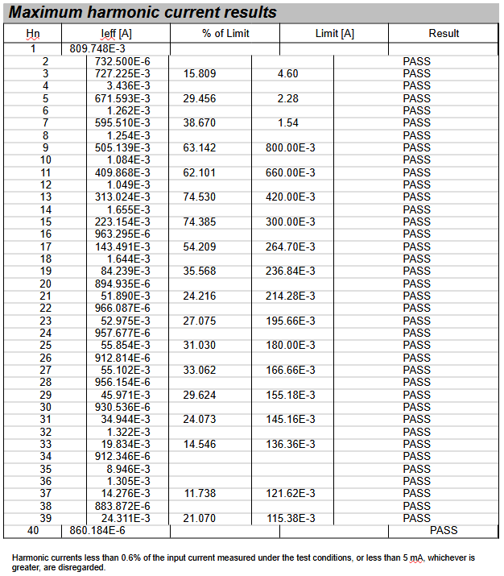
Image 8 – 150W-4 15VDC 10ADC Maximum Current Harmonics Test @Vestel

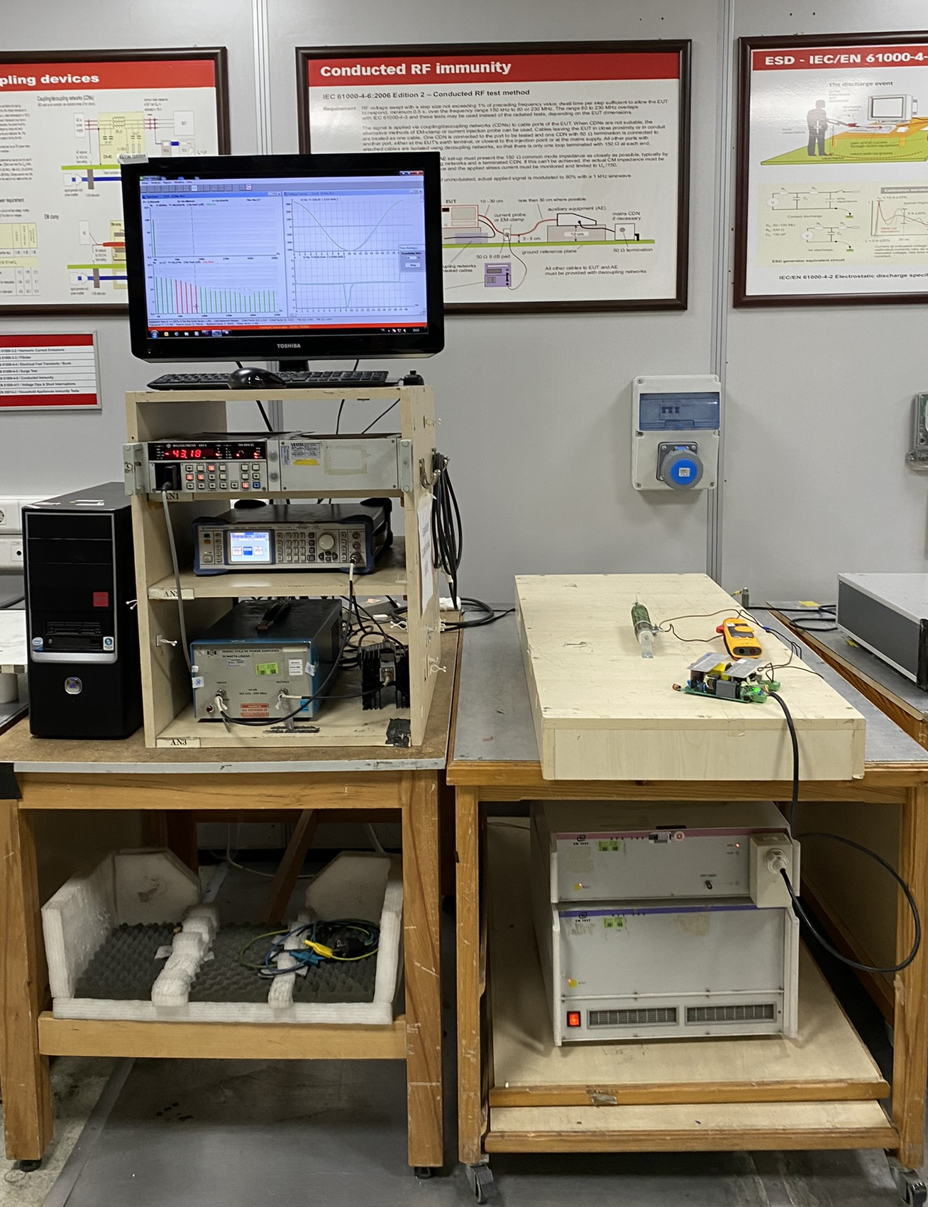
Image 9 – Harmonics Current Measurement Tests Setup @Vestel

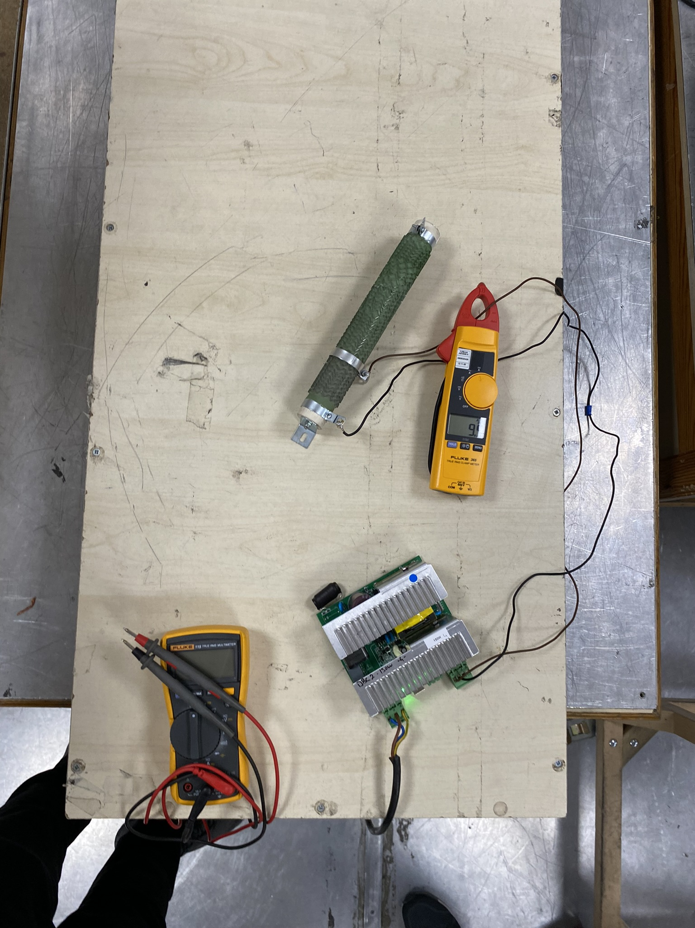
Image 10 - Harmonics Current Measurement Tests Setup @Vestel

Radiated Emissions Tests

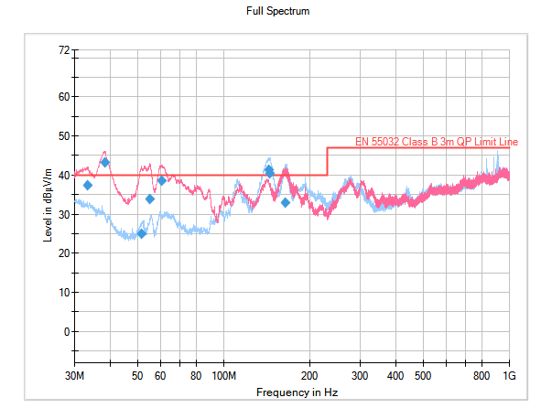
Image 11 – 150W-4 15VDC 10ADC T1 Radiated Test @Vestel

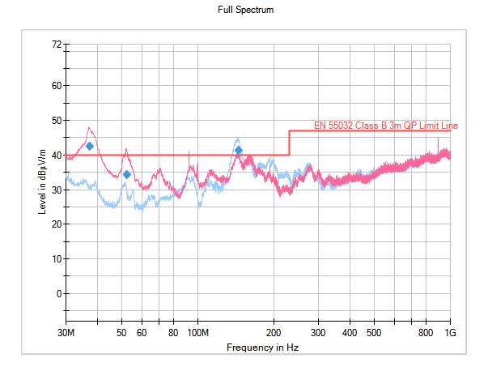
Image 12 – 150W-4 15VDC 10ADC T2 Radiated Test @Vestel
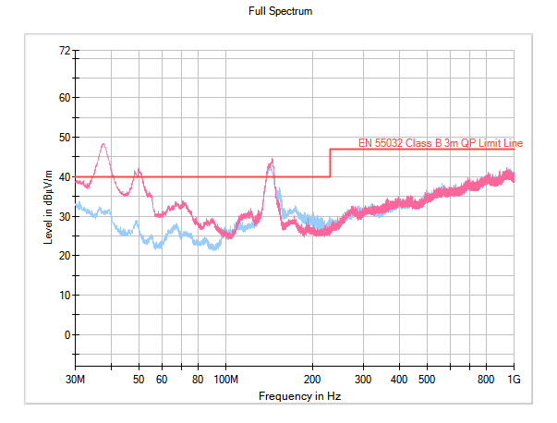
Image 13 – 150W-4 15VDC 10ADC T3 Radiated Test @Vestel
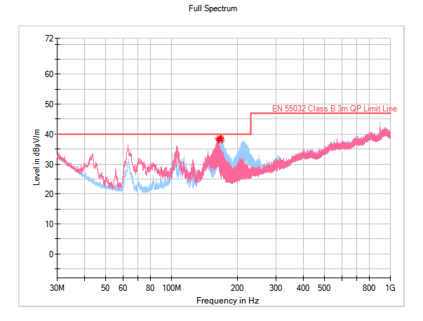
Image 14 – 150W-4 15VDC 10ADC T4 Radiated Test @Vestel

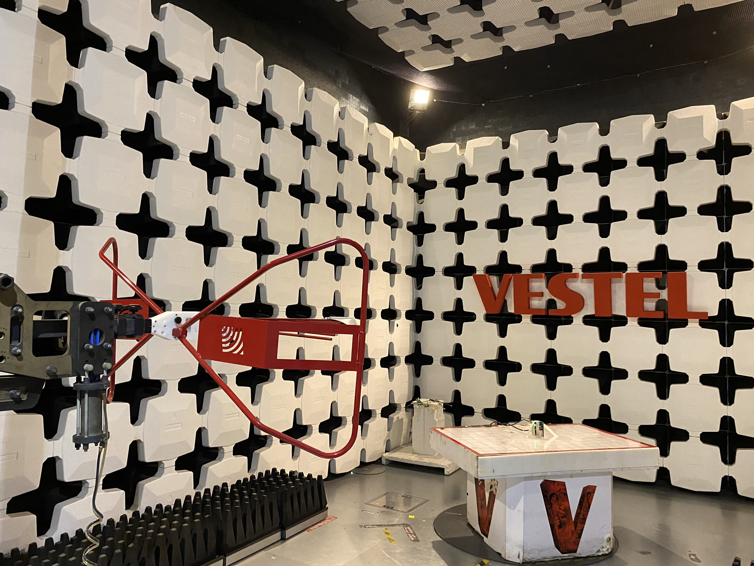
Image 15 – Radiated Tests Setup @Vestel

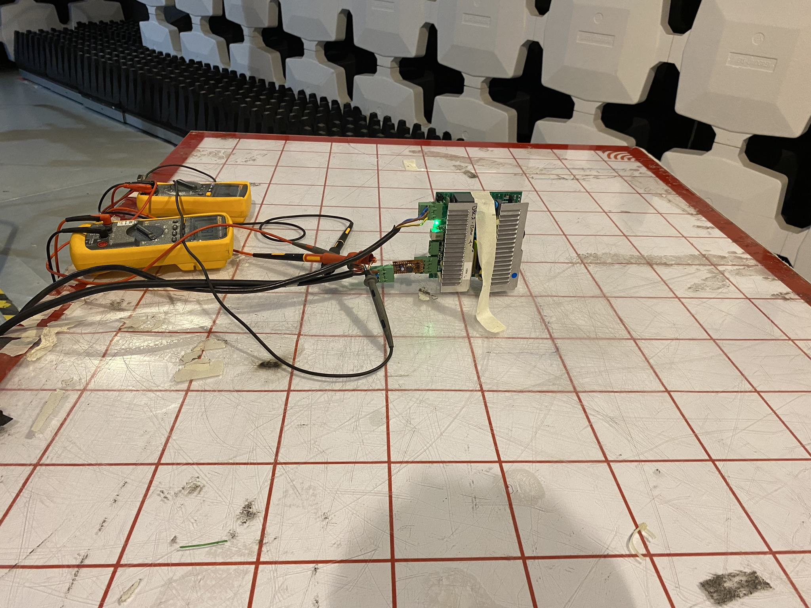
Image 16 – Radiated Tests Setup @Vestel

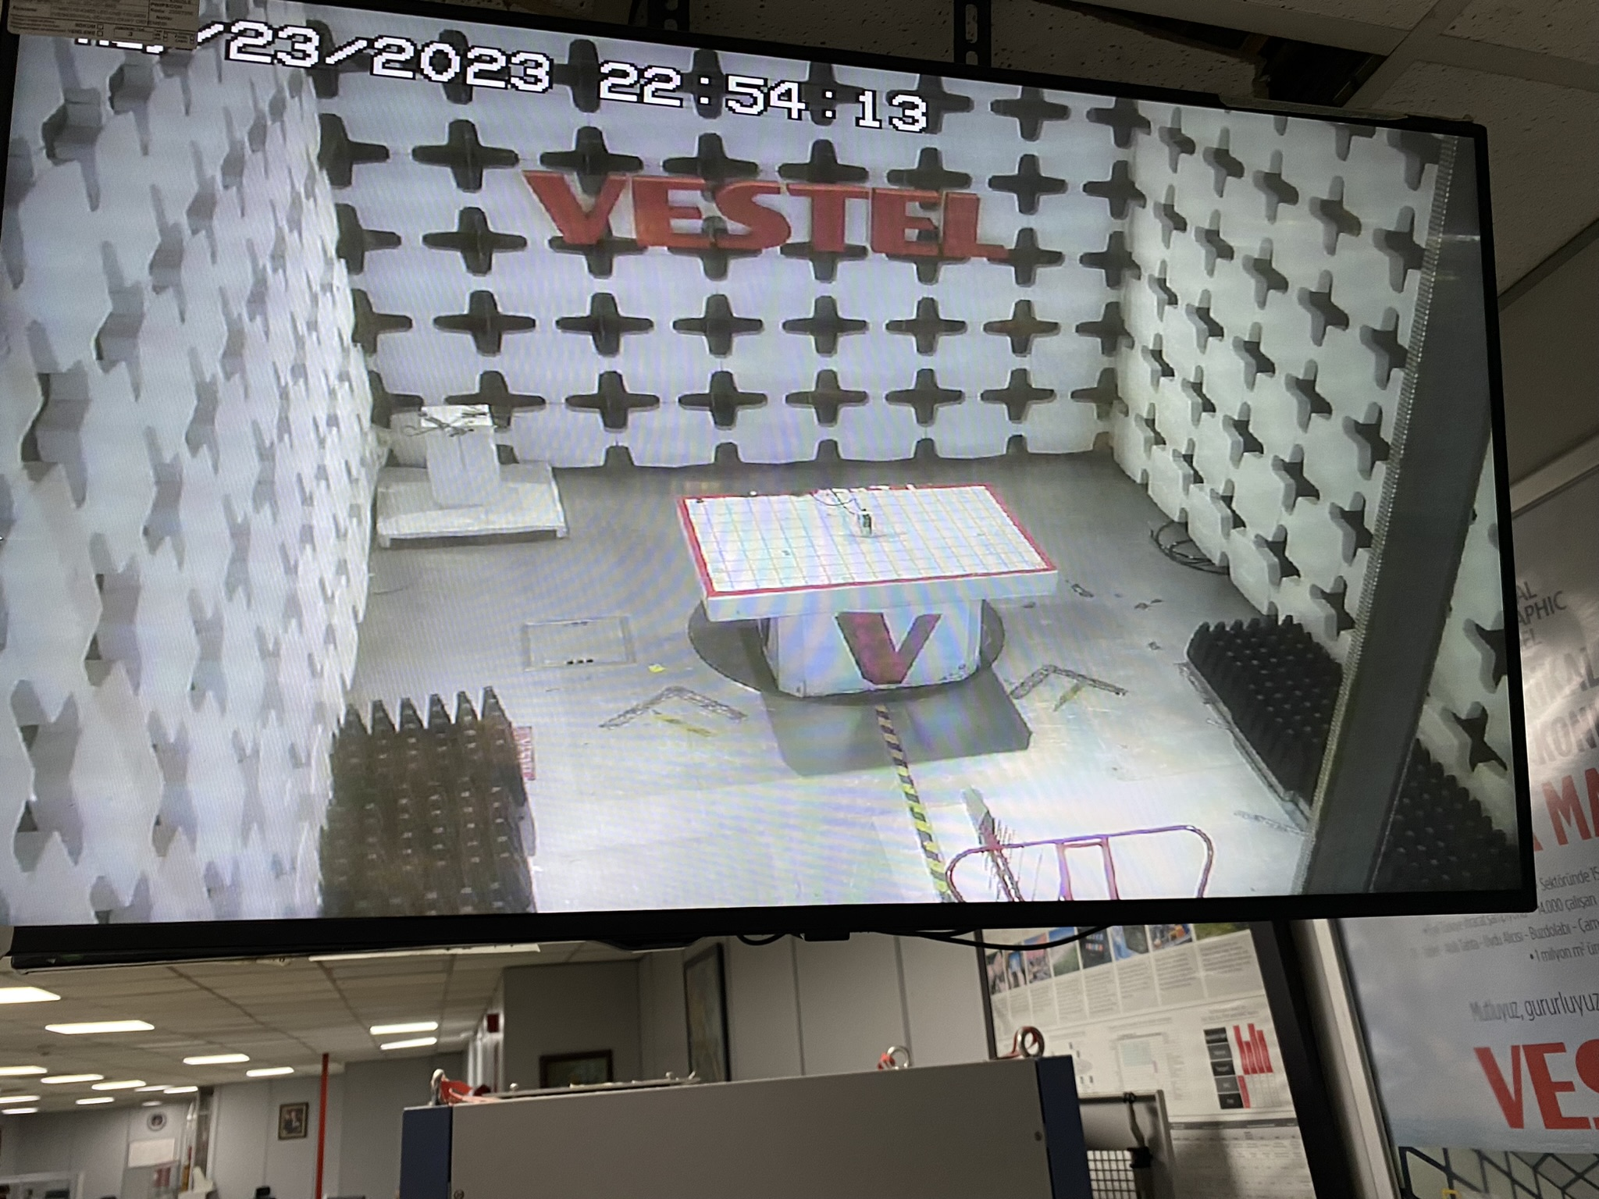
Image 17 – Radiated Tests Setup @Vestel

